Practical 2 Data types and Unit Testing
- Homework Reading Task: Read the ppt summary be found in our courses folder /Powerpoint summaries of Lewis textbook chapters
- Create a project called PBankAccount with a class called BankAccount. The class should have a private integer property called balance and the following constructor and methods. When we create a new BankAccount the balance is always set to zero. For the withdraw method if the balance becomes less than zero deduct a 5 dollar penalty.
BankAccount
- int balance
BankAccount()
+ int getBalance()
+ void deposit(int i)
+ void withdraw(int i)

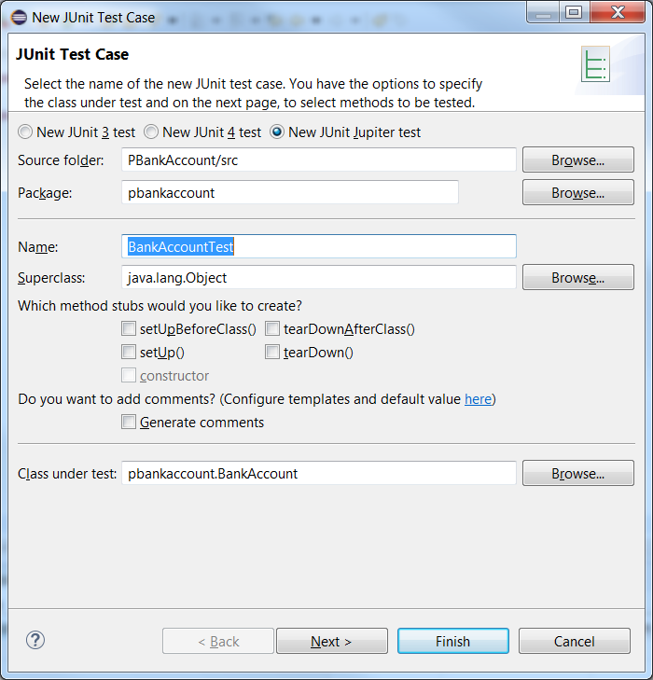
- In the past you have done any testing of your classes in the main method of a class called BankAccountApp. Today we are going to create a test class using JUnit. Right click on the BankAccount.java file and go New|JUnit Test Case.

- Hit Next
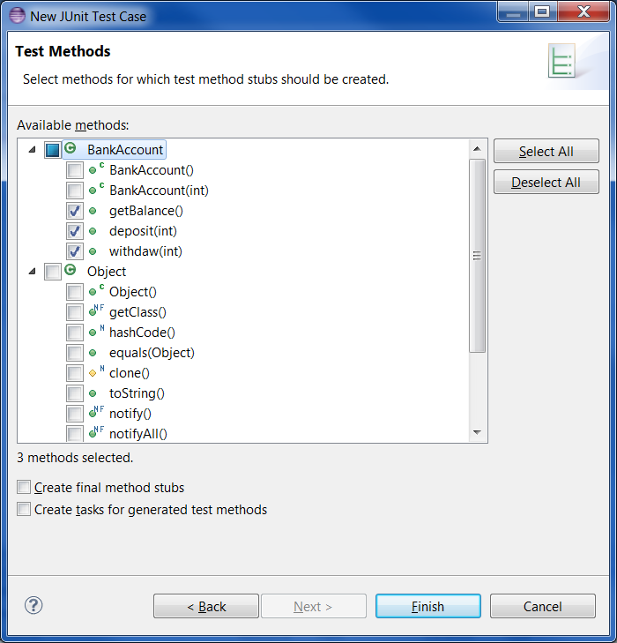
- Eclipse creates the method stubs which we then code into, you must delete the fail("Not yet implemented"); line. When I make a new bank account I expect the balance to be set to zero, so to test the getBalance method and the constructor, I will create a new instance and see that the balance is zero.
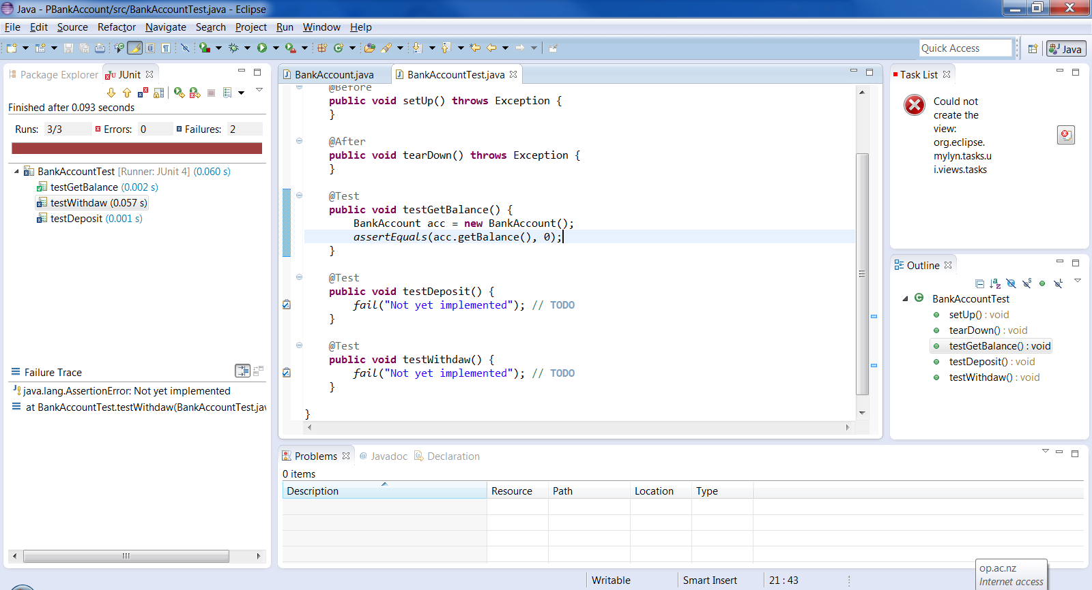
- To make a unit test run- right click inside the Test class and go Run as|JUnit Test
- How will we test the deposit method? Let’s deposit 50 dollars and see that our balance is now 50 dollars.
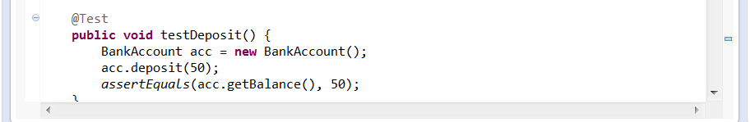
- Now test the withdraw class by first depositing 100 dollars and then withdrawing 50.
- Create another test method called testWithdrawWithPenalty in this one deposit 100 dollars and withdraw150 dollars, what should your balance be?
- Make the BankAccount class more realistic by changing all the integer variables to doubles. Make the corresponding changes to the Test class, note you now need a third parameter in your AssertEquals statement see Table 1 row 5

Assert statements
The following table gives an overview of the available assert statements.
Table 1. Test methods
Statement | Description
fail(String) | Let the method fail. Might be used to check that a certain part of the code is not reached. Or to have failing test before the test code is implemented.
assertTrue(true) / assertTrue(false) | Will always be true / false. Can be used to predefine a test result, if the test is not yet implemented.
assertTrue([message], boolean condition) | Checks that the boolean condition is true.
assertEquals([String message], expected, actual) | Tests that two values are the same. Note: for arrays the reference is checked not the content of the arrays.
assertEquals([String message], expected, actual, delta) | Test that float or double values match. The delta is the acceptable difference between the expected and actual values for which both numbers are still considered equal. e.g. 1e-5 (0.00001)
assertNull([message], object) | Checks that the object is null.
assertNotNull([message], object) | Checks that the object is not null.
assertSame([String], expected, actual) | Checks that both variables refer to the same object.
assertNotSame([String], expected, actual) | Checks that both variables refer to different objects.
assertArrayEquals(int[] expecteds, int[] actuals) | Asserts that two int arrays are equal.

- Your bank pays you interest on an annual basis, write a method called addInterest(). Your interest is 5% of a positive balance but you get taxed on this interest amount by 33%. Add your resulting interest payment to the original balance.
- Write a unit test for this method. If my balance is 1000, I earn $50 interest but then get taxed $16.50, final balance should be $1033.50. Do you agree?
The following table gives an overview of the available annotations in JUnit 4.x.
Table 1. Annotations
Annotation | Description
@Test public void method() | The annotation @Test identifies that a method is a test method.
@Before public void method() | Will execute the method before each test. This method can prepare the test environment (e.g. read input data, initialize the class).
@After public void method() | Will execute the method after each test. This method can cleanup the test environment (e.g. delete temporary data, restore defaults).
@BeforeClass public void method() | Will execute the method once, before the start of all tests. This can be used to perform time intensive activities, for example to connect to a database.
@AfterClass public void method() | Will execute the method once, after all tests have finished. This can be used to perform clean-up activities, for example to disconnect from a database.
@Ignore | Will ignore the test method. This is useful when the underlying code has been changed and the test case has not yet been adapted. Or if the execution time of this test is too long to be included.
@Test (expected = Exception.class) | Fails, if the method does not throw the named exception.
@Test(timeout=100) | Fails, if the method takes longer than 100 milliseconds.
- Make a new project PSalary. Create and test a class that works out your personal income tax. You pay 10.5% for the first $0 to $14,000, 17.5% on $14,001 to $48,000, 30% on $48,001 to $70,000 and 33% from $70,000. Use the calculator http://www.salaries.co.nz/a/salary-tax-calculator/ for the expected values in your test class. Have at least 8 test methods.

Salary
- double:gross
Salary(double gross)
+ double getGross()
+ void setGross(double gross)
+ double getTax()
+double getNet()

- Test driven development (TDD) is a software development approach in which a test is written before writing the code.
Log into https://www.linkedin.com/learning/programming-foundations-test-driven-development-2/.

